Opgave 8

8.1)

The enrollment system contains a list of students and courses. It can display the list of students which are enrolled in a particular course. It is possible to enroll students to a course and remove them from a course.

----------------------------

The enrollment system contains a list of students and courses. It can display the list of students which are enrolled in a particular course. It is possible to enroll students to a course and remove them from a course.

It is possible to add new and remove both students and courses.

8.2)

Funktionelle krav

|  |  |  |
| --- | --- | --- |
| ID | Navn | Beskrivelse |
| F01 | Vis liste over studerende | Det skal være muligt at få vist en liste over studerende. |
| F02 | Vis liste over kurser | Det skal være muligt at få vist en liste af kurser. |
| F03 | Tilføj og fjern tilknytning til kurser | Det skal være muligt at associere studerende til et kursus. Det skal også være muligt at fjerne eksisterende associationer.. |
| F04 | Tilføj og fjern kurser | Det skal være muligt at tilføje nye kurser og fjerne kurser. |
| F05 | Tilføj og fjern studerende | Det skal være muligt at tilføje nye studerende og fjerne studerende |
|  |  |  |
|  |  |  |
|  |  |  |

Non-funktinelle krav

|  |  |  |
| --- | --- | --- |
| ID | Navn | Beskrivelse |
| NF01 | Kapacitet | Systemet skal have plads til 10 kurser. |
| NF02 | Interoperabilitet | Systemet skal kunne integreres med BlackBoard. |
|  |  |  |
|  |  |  |
|  |  |  |
|  |  |  |
|  |  |  |

8.3)

Verb noun metoden:

The enrollment system contains a list of students and courses. It can display the list of students which are enrolled in a particular course. It is possible to enroll students to a course and remove them from a course.

It is possible to add new and remove both students and courses.

|  |  |
| --- | --- |
| **Metoder** | **Klasser** |
| EnrollmentSystem | Enroll |
| Student | Remove |
| Course | Display |
| AddStudent | add |
| RemoveStudent |  |
| AddCourse |  |
| RemoveCourse |  |

8.4)

CRC-kort:

|  |
| --- |
| Enrollment System |
|  |

|  |  |
| --- | --- |
| Responsibilities | Collaborators |
| Contains list of course objects  ‘ | Student |
| Contains list of Student-objects | Course |
| Can enroll Student-objects in Course-objects |  |
| Can remove Students-objects from Course-objects |  |
| Can display Student-objects enrolled in any given Course-object |  |
| Can add new course objects |  |
| Can add new Students objects |  |
| Can remove Students obejcts |  |
| Can remove course objects |  |
|  |  |
|  |  |
|  |  |

8.5)

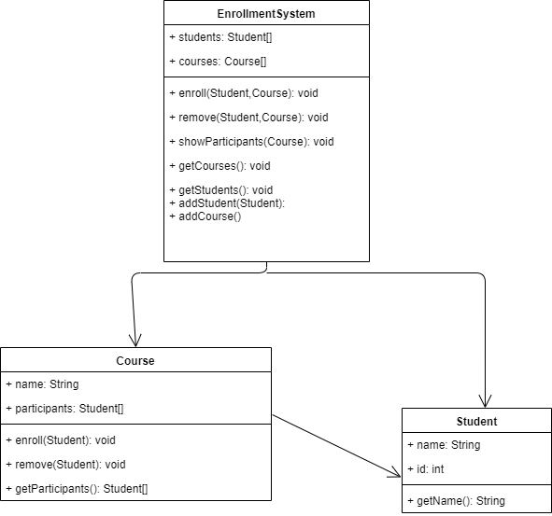

8.6)

Se mappen modulopgave_8 I git.